S3 – GROUP BY - AVG -SUM

# What you will know:

GROUP BY – AVG - SUM

# Instructions: Open [this online SQL editor](https://www.w3schools.com/sql/trysql.asp?filename=trysql_op_in)

**Exercise 1: Databases on W3school**

Each product of **Products** table has a **category ID** (*this ID refers to an element in the* ***Categories*** *table*)

## Q1 : Write a SQL query to display the **number of products per category**.

Expected columns:

CategoryID Number of items

SELECT CategoryID, COUNT(CategoryID) FROM Products GROUP BY (CategoryID) ;

**Your query:**

…………………………………………………………………………………………………………………………………………………………….

## Q2: Write a SQL query to display the **average price** of items per category ID.

Expected columns:

CategoryID Average items price

**SELECT CategoryID, avg(price) FROM Products GROUP BY (CategoryID);**

**Your query:**

…………………………………………………………………………………………………………………………………………………………….

## Q3: Write a SQL query to display the **total of the price** of all items per category ID.

Expected columns:

Category ID Total items price

**SELECT CategoryID, sum(price) FROM Products GROUP BY (CategoryID);**

**Your query:**

…………………………………………………………………………………………………………………………………………………………….

**Exercise 2: World Table**

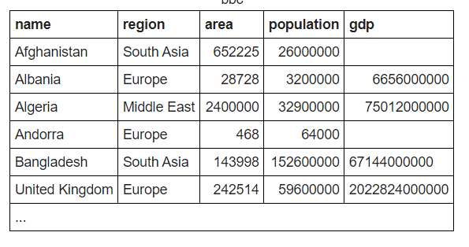

**Q1:** write a statement to sum of population of all countries.

**Your query: select population, sum(population) from group by population (population);**

**Q2** : write a statement to sum of population of all countries in «South Asia»

**Your query: select name, sum(name) from group by name = “South_Asia”;**

**Q3:** write a statement to count GDP is null

**Your query:** select * from world table where gdp > ALL(select gdp from world where gdp is not null);

**Q4**: Write a statemet to showthe number of countries in each continent and group by continents:

**Your query:** SELECT continent, COUNT(*) FROM world GROUP BY continent;

**Q5** : write a statement to show the total population in each continent, group by continents :

**Your query:** SELECT continent FROM world WHERE GROUP BY continent SUM(population);

**Q6 :** For each relevant continent show the number of countries that has a population of at least 200000000.

**Your query:** SELECT continent, COUNT(name) FROM world WHERE population >= 20000000 GROUP BY continent;

Top of Form